2020 China Heat Pump Annual Conference was rounded off successfully

The 2020 China Heat Pump Annual Conference & 9th International Air-source Heat Pump Development Forum was held in Hefei on July 15th-16th. The conference is organized by China Heat Pump Alliance (CHPA) and the Heat Pump Committee of the China Energy Conservation Association (CECA).
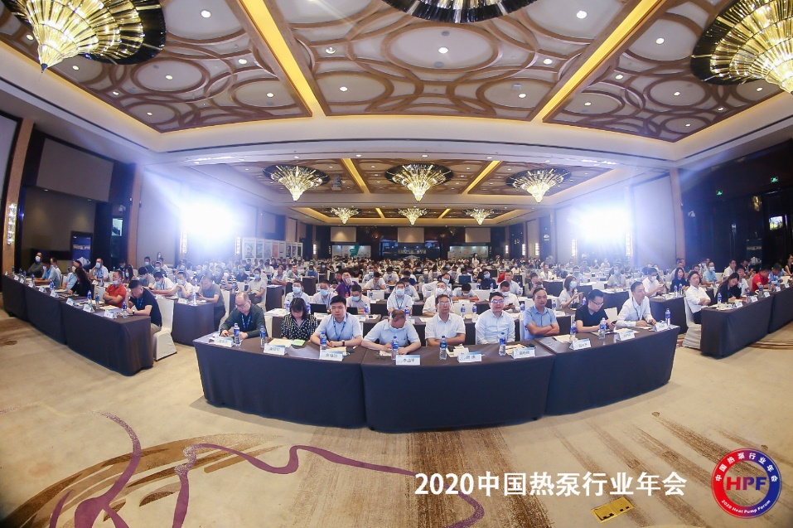
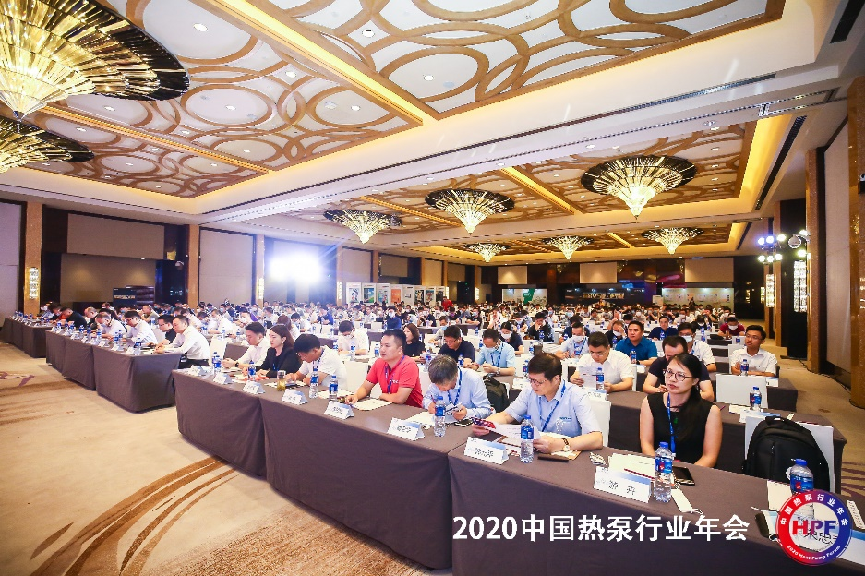
This year's COVID-19 has brought significant challenges to our whole industry. After the epidemic became stable, we overcame many difficulties and held this event. In such a situation, there were still more than 500 delegates participated in this conference. They are from heat pump manufacturers, parts and components suppliers, sales agents, colleges & universities, industry associations, institutes of architectural design and construction, ESCO companies, property development companies, etc.

The forum content included the Development of Hot Water and Renewable Energy Policy, Clean Heating and Project Investment & Financing, Industrial & Agricultural Applications and Drying, Combined heat pump for comfortable heating & cooling, and Sales Channel Development. Experts from industries, universities, and testing laboratories gave more than 30 presentations. International partners, including EHPA, HPTCJ, and Copper alliance, also made presentations.
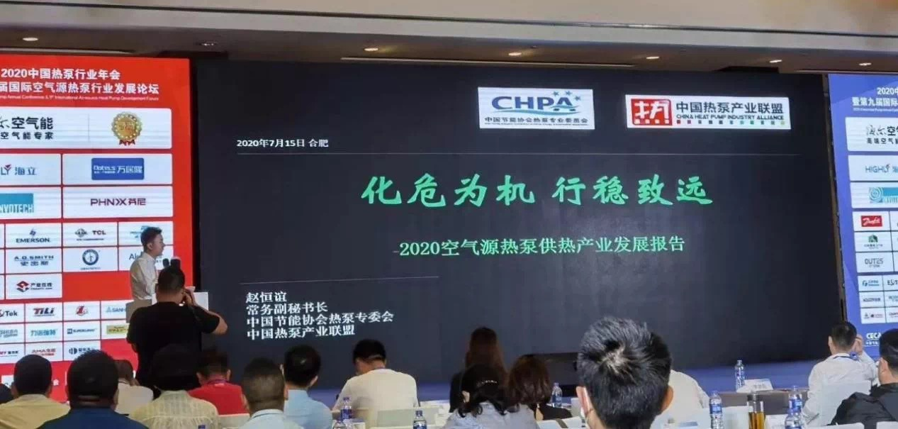
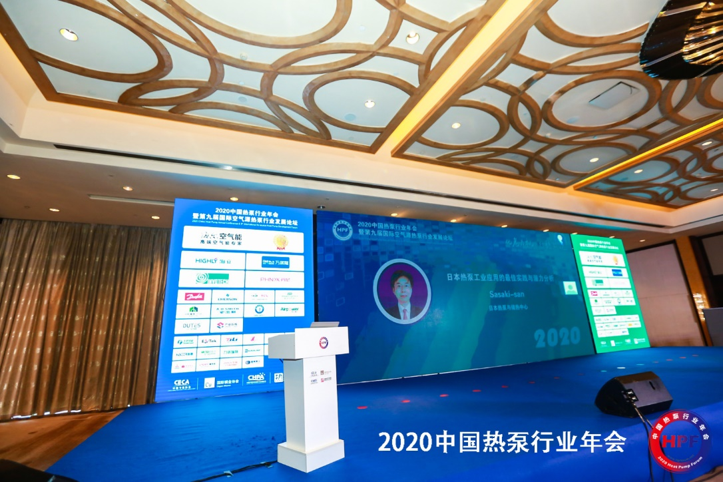

In this conference, CHPA also released the 2020 annual report of China heat pump industry, and also gave awards to leading companies and best projects in China heat pump industry in the year of 2019.
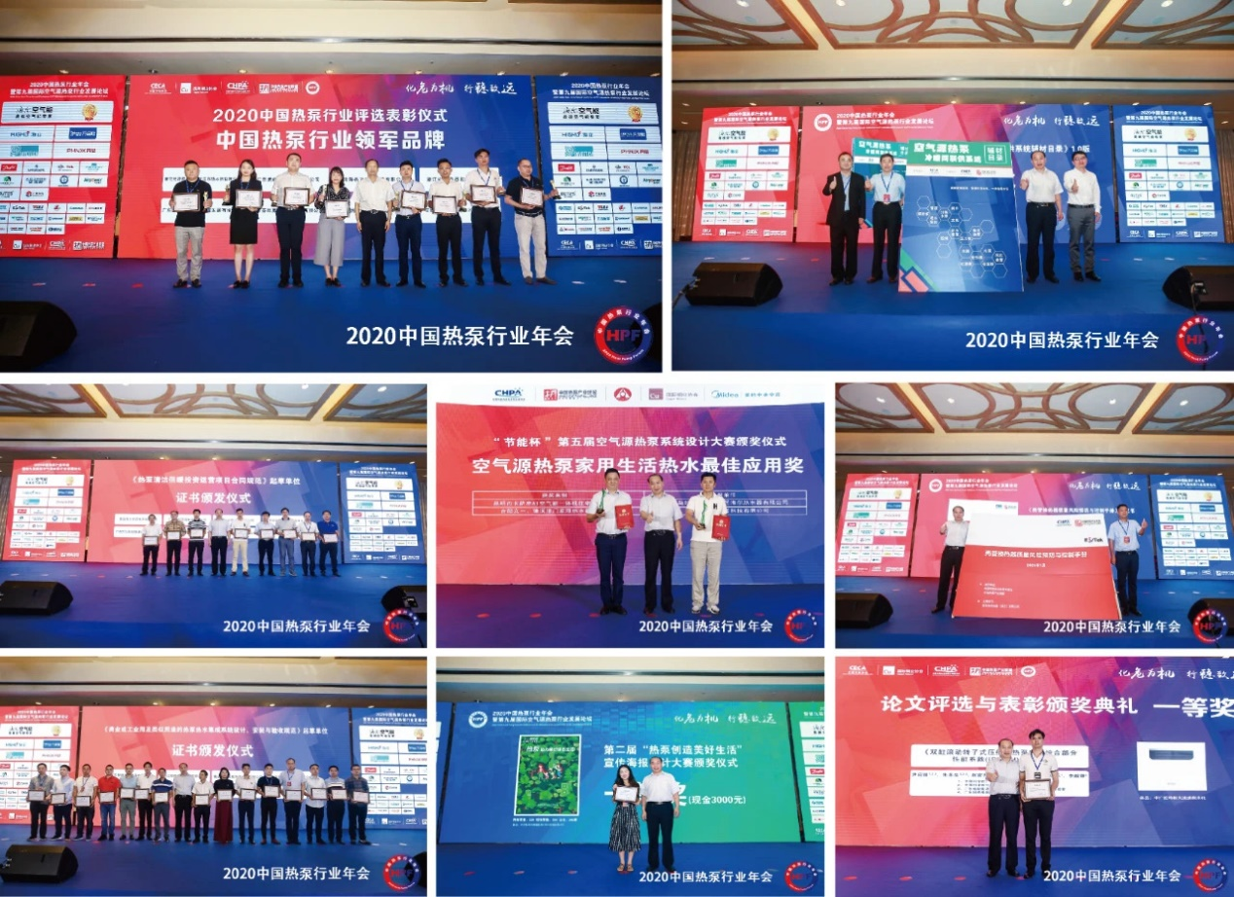

The 2020 China Heat Pump Industry Annual Conference provided an effective platform for the knowledge and experience sharing of heat pump industry; laid a foundation for the popularization and application of heat pump products in heating, domestic hot water, industrial and agricultural drying; facilitated the incorporation of air source energy into renewable energy research, and played a tremendously positive role in promoting the healthy development of the whole industry.

